**Experiment No. 6**

**Aim:** Create and Login application and open a browser with any one search engine.

**Program:**

* **Activity.xml :-**

*<?*xml version="1.0" encoding="utf-8"*?>*<RelativeLayout xmlns:android="http://schemas.android.com/apk/res/android"  
 xmlns:app="http://schemas.android.com/apk/res-auto"  
 xmlns:tools="http://schemas.android.com/tools"  
 android:layout_width="match_parent"  
 android:layout_height="match_parent"  
 tools:context=".MainActivity">  
  
 <TextView  
 android:layout_width="wrap_content"  
 android:layout_height="wrap_content"  
 android:id="@+id/tv1"  
 android:text="Login Form"  
 android:textStyle="bold"  
 android:textSize="35sp"  
 android:layout_centerHorizontal="true"  
 android:layout_marginTop="100dp"/>  
  
 <TextView  
 android:layout_width="wrap_content"  
 android:layout_height="wrap_content"  
 android:id="@+id/tv2"  
 android:text="Name :-"  
 android:textSize="20dp"  
 android:textColor="@color/black"  
 android:layout_marginTop="175dp"/>  
  
 <EditText  
 android:id="@+id/et1"  
 android:layout_width="match_parent"  
 android:layout_height="wrap_content"  
 android:layout_below="@+id/tv1"  
 android:layout_marginLeft="45dp"  
 android:layout_marginTop="15dp"  
 android:layout_toRightOf="@+id/tv2"  
 android:gravity="center"  
 android:hint="Please Enter Your Name"  
 android:minHeight="48dp" />  
 <TextView  
 android:layout_width="wrap_content"  
 android:layout_height="wrap_content"  
 android:id="@+id/tv3"  
 android:text="Password :-"  
 android:textColor="@color/black"  
 android:textSize="20dp"  
 android:layout_marginTop="235dp"/>  
 <EditText  
 android:layout_width="match_parent"  
 android:layout_height="wrap_content"  
 android:id="@+id/et2"  
 android:layout_below="@+id/et1"  
 android:layout_marginLeft="15dp"  
 android:layout_marginTop="15dp"  
 android:layout_toRightOf="@+id/tv3"  
  
 android:gravity="center"  
 android:hint="Please Enter Your Password"  
 android:inputType="textPassword"  
 android:minHeight="48dp"/>  
 <Button  
 android:id="@+id/log"  
 android:layout_width="wrap_content"  
 android:layout_height="wrap_content"  
 android:layout_marginTop="35dp"  
 android:padding="13dp"  
 android:layout_marginLeft="175dp"  
 android:layout_below="@+id/et2"  
 android:text="Login"  
 android:onClick="click" />  
  
</RelativeLayout>

* **MainActivity.java :-**

package com.example.insta;  
  
import androidx.appcompat.app.AppCompatActivity;  
  
import android.content.Intent;  
import android.net.Uri;  
import android.os.Bundle;  
import android.view.View;  
import android.widget.Button;  
import android.widget.EditText;  
import android.widget.Toast;  
  
public class MainActivity extends AppCompatActivity {  
 EditText et1, et2;  
 Button log;  
 String username, password;  
  
 @Override  
 protected void onCreate(Bundle savedInstanceState) {  
 super.onCreate(savedInstanceState);  
 setContentView(R.layout.*activity_main*);  
 et1=findViewById(R.id.*et1*);  
 et2=findViewById(R.id.*et2*);  
 log=findViewById(R.id.*log*);  
 }  
  
  
 public void click(View view) {  
 username= et1.getText().toString();  
 password= et2.getText().toString();  
 if(username.equals("Shruti Gurav") && password.equals("1227")){  
 Intent intent = new Intent(Intent.*ACTION_VIEW*);  
 intent.setData(Uri.*parse*("https://www.google.com/"));  
 startActivity(intent);  
 }  
 else{  
 Toast.*makeText*(this, "Login Failed", Toast.*LENGTH_SHORT*).show();  
 }  
 }  
}

**Output:**

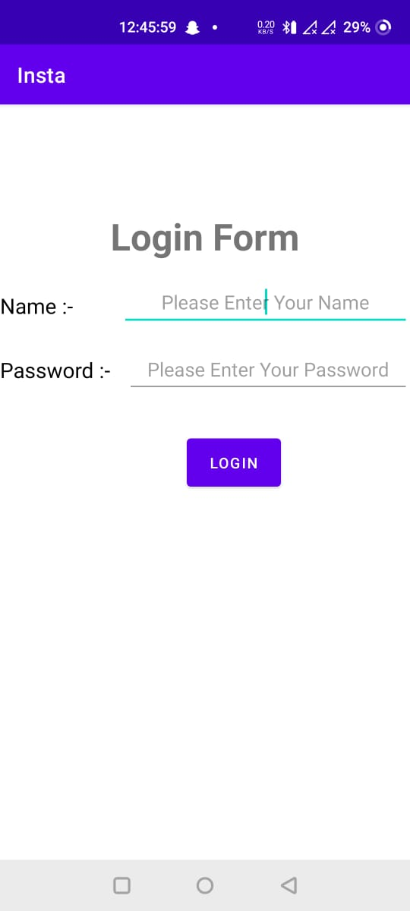 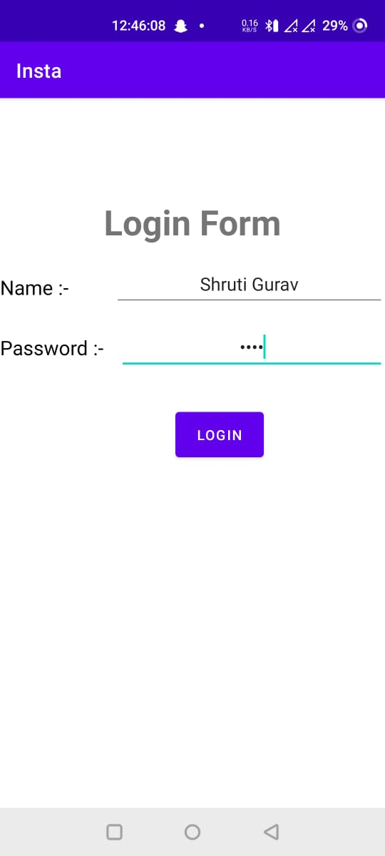

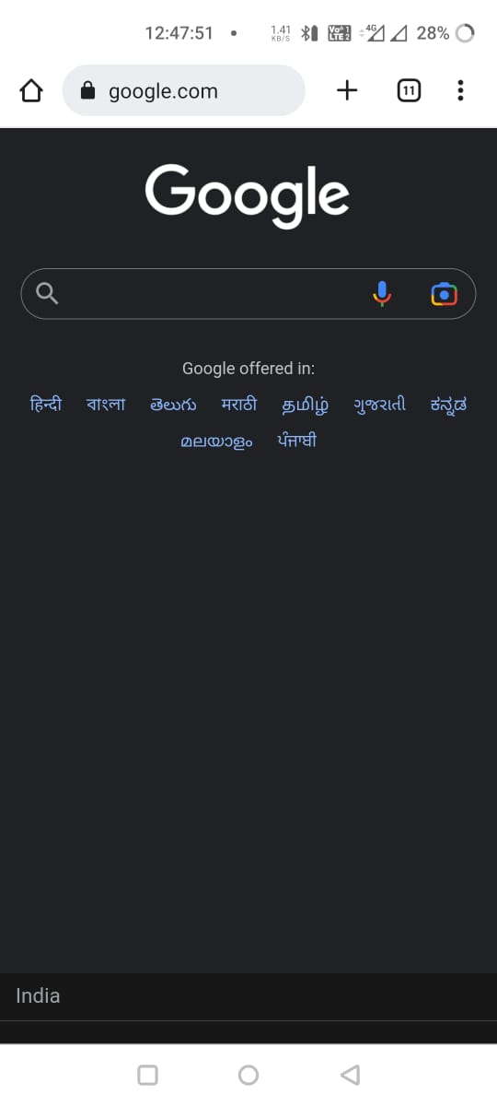 

**Conclusion:**

Hence, by completing this experiment I came to know that how to Create and Login application and open a browser with any one search engine.

|  |  |  |  |
| --- | --- | --- | --- |
| **Writeup & Oral**  **(4)** | **Practical Performance**  **(4)** | **Attendance**  **(2)** | **Total**  **(10)** |
|  |  |  |  |